**Nama : Raihan Eka Saputra**

**NIM : 2009076001**

**Prodi : Teknik Elektro**

**Matakuliah : Metode Numerik**

Diketahui:

Image

Image

Image

Penyelesaian:

v Gauss Naif

Image

Langkah:

· Image

· Image

· Image

· Image

Hasil:

Ø

Ø Image

Image

Image

Ø Image

Image

Image

Ø

Ø Image

Image

Image

Image

v Gauss Jordan

Image

Langkah:

*1) Image*

*2) Image*

*3) Image*

*4) Image*

*5) 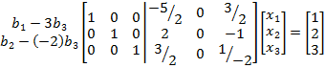*

Jadi: Image

Image

Image